Advance Software Engineering Lab Report 10(Lab-Id 5_1)

Name: Harika and Sumanth

Class Id: 15, 20

Team number: 5_1

ICP team: 5

# Approach: 1)Using AWS Lambda with Amazon S3

# 2)Lambda and s3 image resize application

Code Explanation:

In Amazon AWS account, we need to create one or more IAM users , if we are creating a new application that needs to make API calls to AWS, and with our AWS root user account, our access keyid and secret access key will expire soon, so for that we need to create IAM user and provide administrative permission to that user, in order to perform any task

**Steps to create a IAM user**

* We need to open IAM under services in AWS ,and click on users and press ADD user button and following page will appear

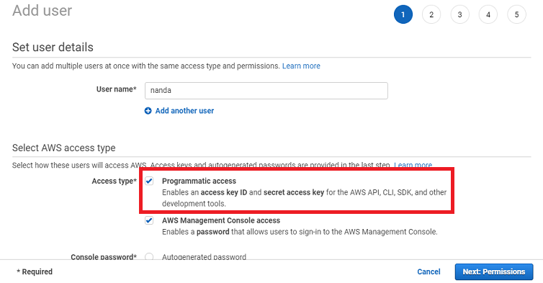

* We need to check programmatic access, which enables IAM user to use for AWS API, CLI, and other tools. We can also check AWS Management Console access, if we want to give password to IAM user and then press Permissions as shown above

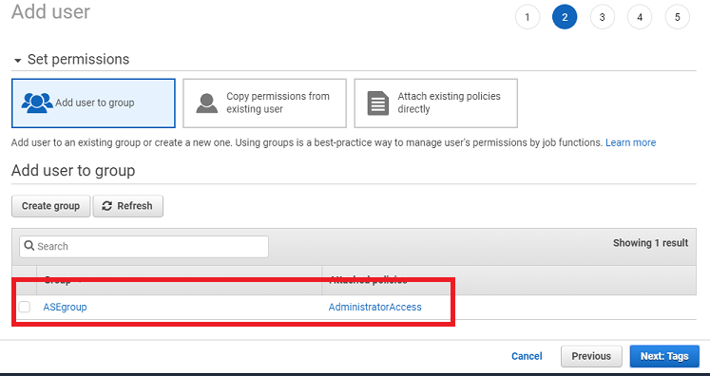

* We can create a group, and give permissions to the group. I have already given administrator Access to the “ASEgroup” and click Tags as shown above

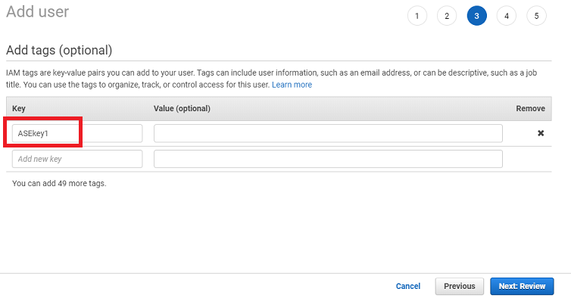

* I have given ASEkey1 as my tag key name and press review as shown above

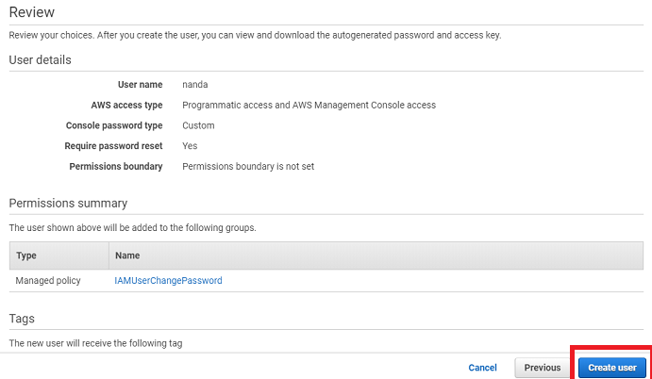

* We can review here what permissions are given to above user and press create user button as shown in the above screenshot

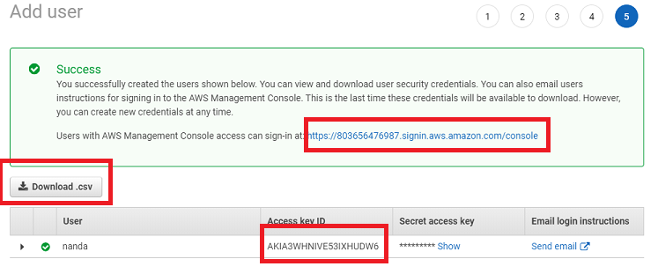

* User created successfully and we can see Access key id, secret access key above, and we can download .csv file, which contains secret key details

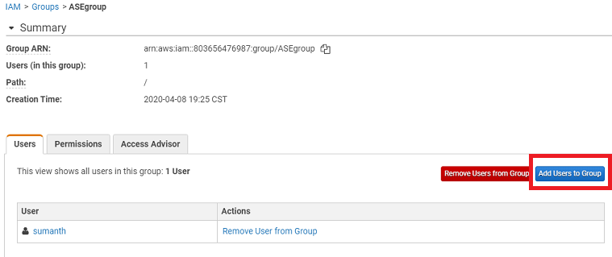

* We need to add our user to the above group “ASEgroup” as we have already created , so that user can have “administrative access” ,which was given to the group, by clicking on add users to group button

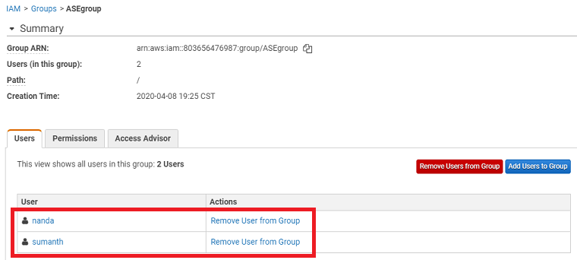

* Now we can see nanda user got added to the above group

**Installing the AWS CLI version 2**

* We need to install AWS CLI version 2 for windows and then we need to verify by running the below command

aws –version

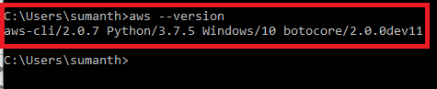

# Configuring the AWS CLI

Here we need to configure the security credentials, the default output format, and the default AWS Region by giving below command

>aws configure

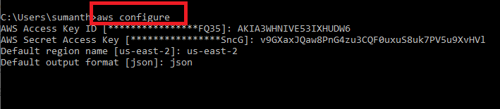

**Lambda function**

* We need to create 2 buckets

1) myasebucket and uploaded HappyFace.jpg inside bucket

2) myasebucket-resized

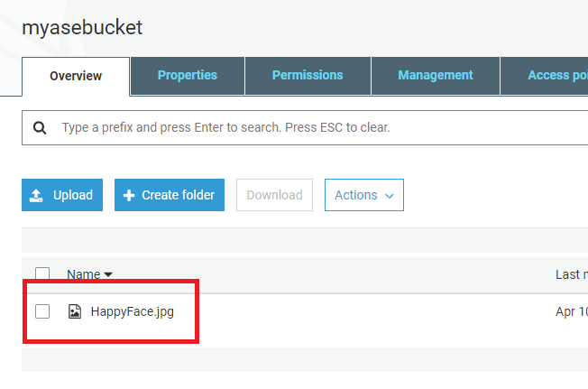

* Create new directory myfuction and copy index.js file inside it ,and run npm install sharp module inside it

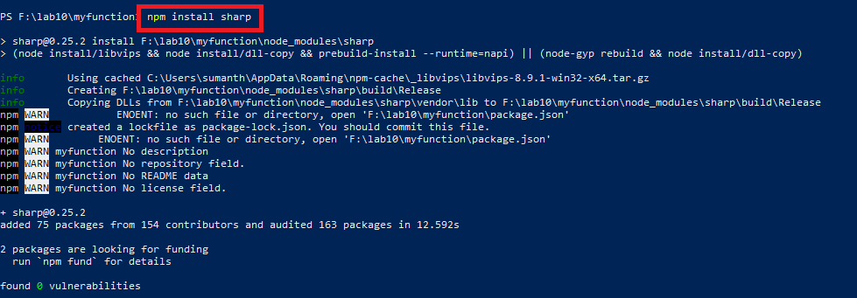

* Convert myfunction folder into myfunction.zip and run the below command i.e,create lambda function as shown in screenshot

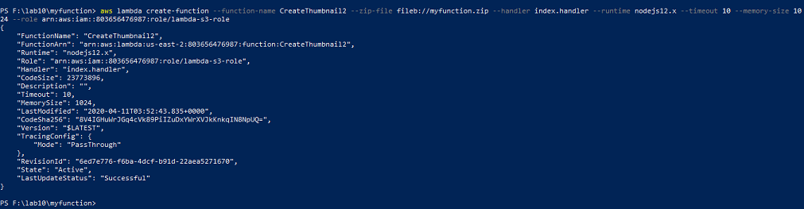

* We need to create a lambda execution role by giving policy “AWSLambdaExecute”, and we need to pass Role ARN in above lambda function command

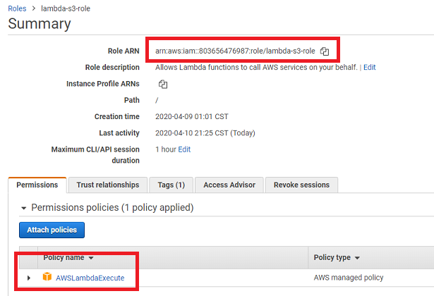

* We can see the CreateThumbnail2 lambda function got created , next we need to configure the event

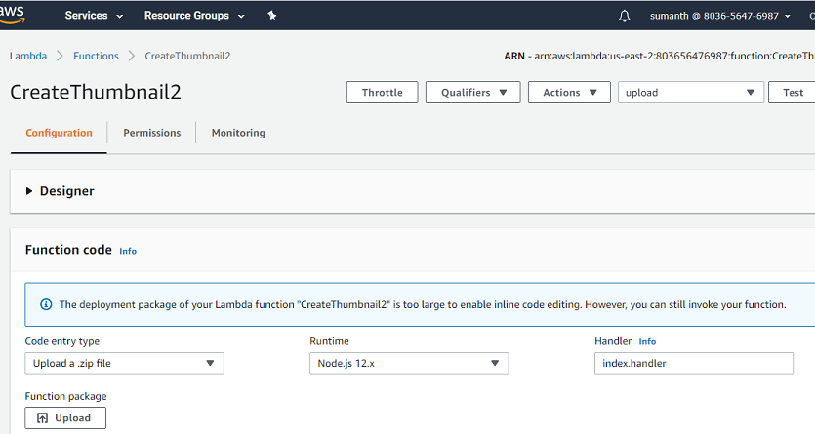

* We need to configure event by giving amazon s3 put , and I have given my event name as upload
* We need to give our image name and source bucket name as shown below

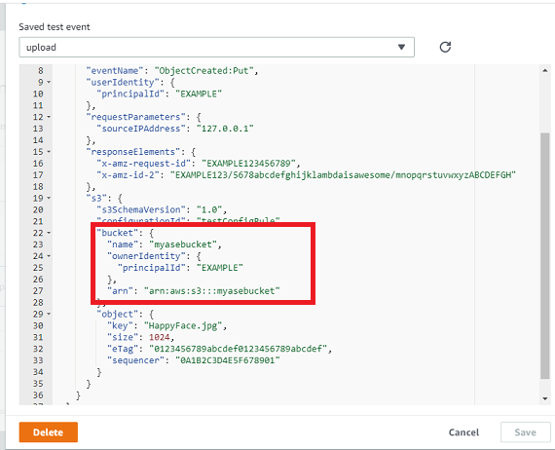

* After testing lambda function, we need to open our destination bucket and we can find resized-HappyFace.jpg image present

